
Lesson 7: On the Move
TIC-80
VIDEO GAME CREATION
This week: enemies stop standing still. Your job is to make every enemy advance slowly toward the player, and clean up any that reach the bottom of the screen without being shot.
Open your own [YourName]Game project from Lesson 6 - don't start a new one.
Tip: no new assets this week - this is a logic-only lesson.

Setup
- Launch TIC-80 and load your cart from Lesson 6.
- Press Esc to reach the code editor.

Level 1 - Minimal (MVP)
Every enemy moves slowly downward, toward the player, instead of sitting still. An enemy that reaches the bottom of the screen unshot is removed - and does NOT count toward your win condition, since it escaped rather than being defeated.
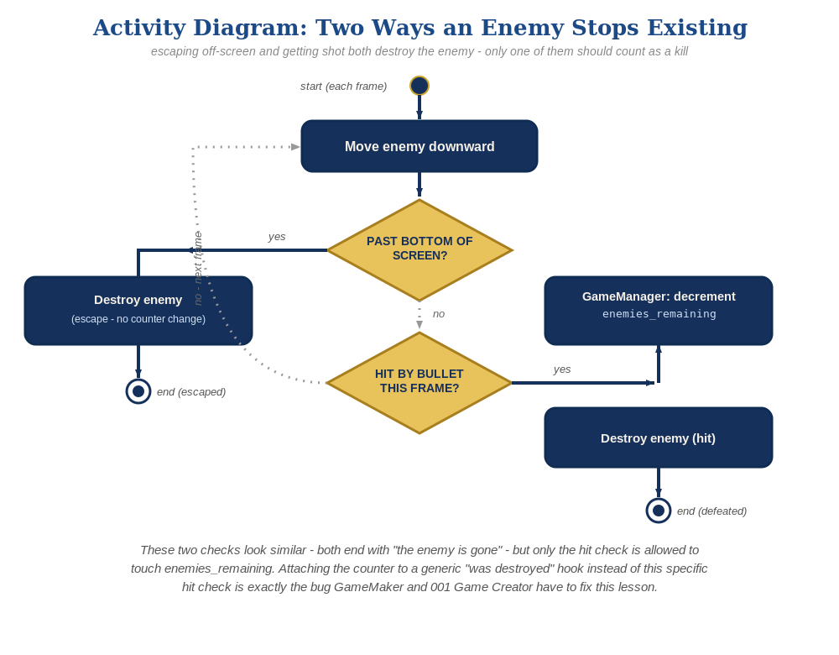
The general escape-vs-hit distinction behind this week's exercise - the same shape in every engine, whatever the exact code or blocks look like.
- In the enemy-drawing loop at the bottom of TIC(), add movement (enemy.ey=enemy.ey+0.3) before the alive check, and a new check that sets enemy.alive=false if an enemy passes the bottom of the screen - without touching enemies_remaining (code below).
- Press Esc, type run, press Enter, then let the enemies drift downward to test - shooting one should still work exactly as before, and letting one reach the bottom unshot should just make it vanish, with no "You Win!" message.
for enemy_index=1,#enemies do
local enemy=enemies[enemy_index]
if enemy.alive then
enemy.ey=enemy.ey+0.3
if enemy.ey>136 then
enemy.alive=false
else
spr(3,enemy.ex,enemy.ey,0)
end
end
end

Level 2 - Complete (Alpha/Beta)
A moving enemy can still be shot and destroyed correctly, and an enemy that escapes off the bottom never triggers "You Win!" by accident.
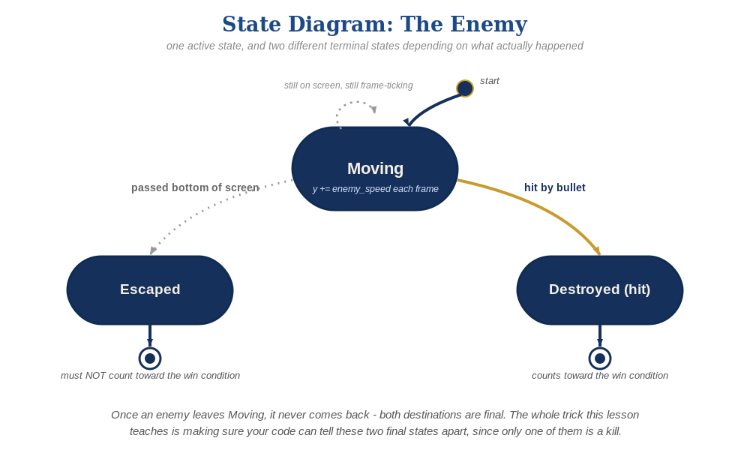
The enemy's two possible endings this week - only one of them should count as a kill.
- Shoot a moving enemy to confirm the bullets-vs-enemies collision check still works correctly while it's in motion.
- Let at least one enemy escape off the bottom unshot, and confirm "You Win!" does NOT appear - only the collision branch inside the bullets loop (guarded by enemy.alive and the overlap check) ever decrements enemies_remaining, and the movement loop's escape check never touches it.

Level 3 - Refined (Ready to Publish) - pick any that interest you
- Visual: give each enemy a slightly different descent speed based on its table index enemy_index (e.g. enemy.ey=enemy.ey+0.2+enemy_index*0.05) so they don't all move in perfect lockstep.
- Structure: keep the movement/escape-cleanup loop and the bullets-vs-enemies collision loop as two clearly separate blocks (as shown above) - resist merging them into one loop even though both touch the enemies table.

If Something's Wrong
- "You Win!" appears even when enemies escaped unshot: confirm enemies_remaining is decremented only inside the bullets loop's collision branch, never inside the enemy-drawing loop.
- Enemies don't move: confirm enemy.ey=enemy.ey+0.3 is inside the if enemy.alive then branch of the drawing loop, not skipped or placed outside it.
- Enemies move but never disappear at the bottom: confirm the enemy.ey>136 threshold actually matches TIC-80's 136-pixel-tall default screen - adjust if you changed resolution.

Want More?
Student Resource List > TIC-80 section, or tic80.com

